**Supplemental Materials**

**Appendix A:** Characters from each Show and Intercoder Reliabilities. Characters highlighted were removed from analysis reported in the paper due to low intercoder reliability.

|  |  |  |  |  |
| --- | --- | --- | --- | --- |
| Character | Show | Gender | Ethnicity | Krippendorff’s alpha |
| Bob_Harper | BL | M | White | 0.629 |
| Dolvett_Quince | BL | M | Black | 1 |
| Jennifer_Widerstrom | BL | F | White | 0.789 |
| Alex | CEG | M | Asian | Undefined |
| Chris | CEG | M | Asian | Undefined |
| Dancer | CEG | F | White | 0 |
| Darryl_Whitefeather | CEG | M | White | Undefined |
| Greg_Serrano | CEG | M | White | 0.658 |
| Heather_Davis | CEG | F | Other | Undefined |
| Hector | CEG | M | Other | Undefined |
| Josh_Chan | CEG | M | Asian | 0.887 |
| Kernel_Girl | CEG | F | Asian | 1 |
| Lourdes_Chan | CEG | F | Asian | Undefined |
| Marco_Serrano | CEG | M | White | Undefined |
| Mrs_Hernandez | CEG | F | White | Undefined |
| Paula_Proctor | CEG | F | White | 0.900 |
| Rebecca_Bunch | CEG | F | White | 0 |
| Scott_Proctor | CEG | M | White | Undefined |
| White_Josh | CEG | M | White | 0 |
| Alex_Parrish | Q | F | Other | 0.895 |
| Carl_Adams | Q | M | White | -0.025 |
| Customs_Agent | Q | F | Black | 1 |
| Dayana_Mampasi | Q | F | Black | -0.012 |
| Female_Instructor | Q | F | White | 0.658 |
| First_Lady_Todd | Q | F | White | 1 |
| Harry_Doyle | Q | M | White | 0.725 |
| Jason | Q | M | Other | 0 |
| Jeremy_Miller | Q | M | White | 0.368 |
| Leon_Velez | Q | M | White | -0.025 |
| Lydia_Bates | Q | F | Black | 0.774 |
| Matthew_Keyes | Q | M | White | 0.845 |
| Miranda_Shaw | Q | F | Black | Undefined |
| ND_Agent | Q | M | White | 1 |
| ND_Office_Worker | Q | F | Asian | 1 |
| Nimah_Amin | Q | F | White | 0.644 |
| Owen_Hall | Q | M | Black | -0.025 |
| President_Todd | Q | M | Black | 1 |
| Reporter | Q | M | White | 1 |
| Ryan_Booth | Q | M | White | 0.847 |
| Sebastian_Chen | Q | M | Asian | -0.025 |
| Secret_Service_Agent | Q | F | White | Undefined |
| Shelby_Wyatt | Q | F | White | 0.944 |
| Springer | Q | M | White | Undefined |
| Barbara_Corcoran | ST | F | White | 0.732 |
| Chris_Sacca | ST | M | White | 1 |
| Daymond_John | ST | M | Black | 0.797 |
| Kevin_O_Leary | ST | M | White | 0.662 |
| Lori_Greiner | ST | F | White | -0.025 |
| Mark_Cuban | ST | M | White | 0.764 |
| Robert_Herjavec | ST | M | White | 0.368 |
| Attractive_Woman | TF | F | White | Undefined |
| Barricade_Cop | TF | F | White | Undefined |
| Barry_Allen | TF | M | White | 0.368 |
| Caitlin_Snow | TF | F | White | Undefined |
| Cisco_Ramon | TF | M | Other | Undefined |
| Edward_Clariss | TF | M | White | -0.012 |
| Eobard_Thawne | TF | M | White | 0.868 |
| Harry_Wells | TF | M | White | Undefined |
| Henry_Allen | TF | M | White | 0.789 |
| Iris_West | TF | F | Black | 0.891 |
| Joe_West | TF | M | Black | Undefined |
| Julio_Mendez | TF | M | Black | 0.644 |
| Nora_Allen | TF | F | White | 0.806 |
| Uniformed_Cop | TF | M | Asain | 0.644 |
| Wally_West | TF | M | Black | Undefined |
| April | TM | F | White | Undefined |
| Axl_Heck | TM | M | White | 0.926 |
| Brad_Bottig | TM | M | White | Undefined |
| Brick_Heck | TM | M | White | 0.891 |
| Cindy | TM | F | White | 0.480 |
| Duncan | TM | M | White | Undefined |
| Frankie_Heck | TM | F | White | 1 |
| Freshman_Boy | TM | M | White | Undefined |
| Freshman_Girl | TM | F | White | Undefined |
| Jeremy | TM | M | White | -0.012 |
| Mike_Heck | TM | M | White | 0.876 |
| Sue_Heck | TM | F | White | 0.739 |

*Note*. BL = The Biggest Loser, CEG = Crazy Ex-girlfriend, ST = Stark Tank, TF = The Flash, TM = The Middle

**Appendix B**: Testing the CRT Performance for Characters of Different Genders and Ethnicities through ROC analyses.

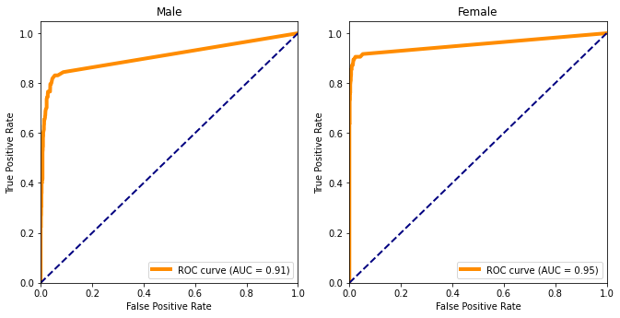

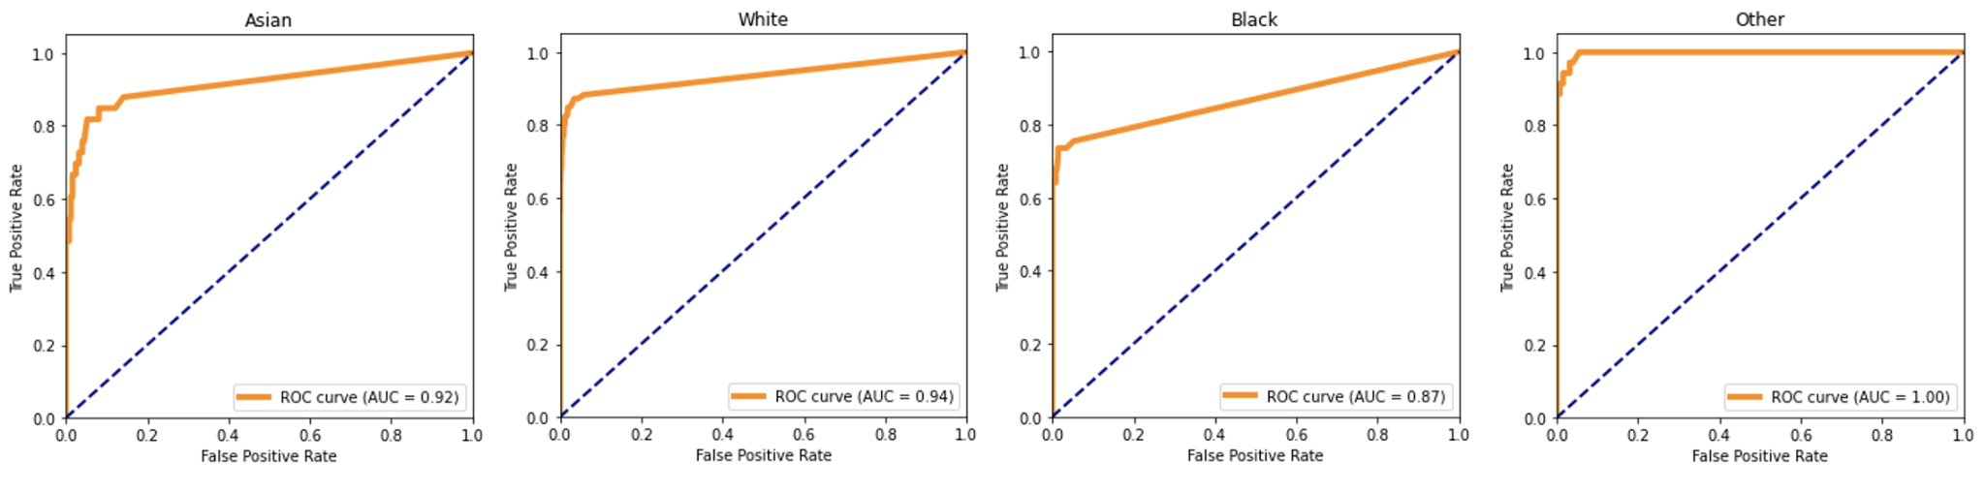

**Appendix C**: The CRT Performance with all Characters (Including those with low intercoder reliabilities).

